39.41: The de Broglie wavelength of the blood cell is
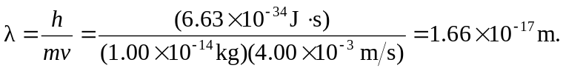
We need not be concerned about wave behavior.

